**VISIO II Export Suitcase**

**Development and upgrade of a suitcase embedded software**

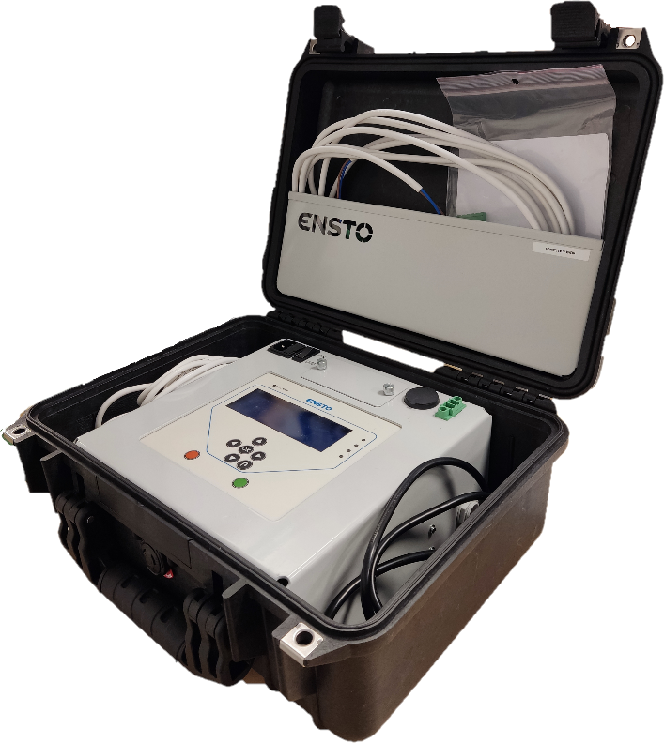

**Company tutor: M Bertrand FAVEL**

**School supervisor: M Serge MAZAURIC**

**Batiste LALOI | February 2022 | CPE LYON – 3IRC**

This report outlines the development process of a software implemented on a suitcase used by field officers to test electrical equipment all around Europe. In the first time, I’ll give a brief presentation of the company I’m currently in which I’m currently employed, then I will end by explaining more precisely what I’ve been working on, by giving the context and the stakes of the project.

My company: Ensto Novexia

Ensto Novexia is one of the main actors in the electrical controlling and monitoring market in the Europe, and especially in France. The company is offering a lot of hardware and software solutions to institutions and municipalities, and those are Ensto Novexia main products:

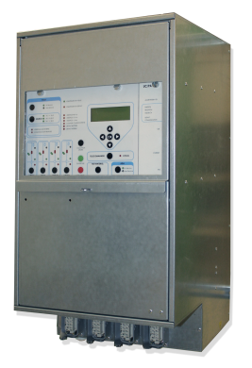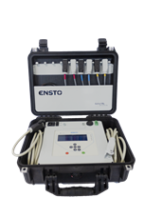

Fig.1: control and monitoring case

Fig.2: VISIO II Suitcase

The project: VISIO II Export suitcase

As I said before, I’ve been working on the embedded software implemented in a test suitcase: it consists of a program written in the C programming language, used in every embedded products since the 70’s. The suitcase is supposed to be plugged into the electrical controlling device (cf. fig.1), and allows to test the device’s fault detection system by injecting high current and/or high voltage.

My role in the company is to update, upgrade and enhance the program responsible of the user interface. Therefore I’m coding in C throughout the day, trying to answer demands coming from the customer service to add or modify the range of feature available on the suitcase.

Using cutting-edge development technologies allow me to discover a brand new facet of programming, and would recommend my company to any oncoming IRC student for their work-study scholarship.